# Guide for installing R, R Studio, and packages required to run the IPR asset model on Windows 10

## R installation (ver. 3.6.0)

Visit <https://cran.ma.imperial.ac.uk/> and click ‘Download R for Windows’, then ‘base’, then ‘Download R 3.6.0 for Windows’

Run the downloaded exe file

Install in default location – should be ‘C:\Users\<username>\R\R-3.6.0’

Accept all other defaults (shortcuts optional – you won’t need them once you have RStudio (IDE for R))

Finish (R (with basic GUI) now installed)

## RStudio installation (ver. 1.2.1335)

Visit <https://www.rstudio.com/products/rstudio/download/>, click ‘RStudio Desktop’ free and select the relevant RStudio installation option for Windows 10 (Windows 7+ (64-bit) at time of writing

Run the downloaded exe file (may require admin privileges)

Install in default location – should be ‘C:\Program Files\RStudio’ (accept all other defaults)

Finish (RStudio IDE for R now installed)

## Rtools installation (ver. 35)

Visit <https://cran.r-project.org/bin/windows/Rtools/>, click on the recommended download version (Rtools35.exe at time of writing)

Run the downloaded exe file

Install in default location – should be ‘C:\Rtools’ (accept all other defaults)

Finish (Rtools is never used directly, and is called by R when trying to do certain things)

## Add Rtools to Windows system path (allows R and RStudio to find Rtools)

Type ‘path’ into the Start menu and click ‘Edit the system environment variables’, you may need to click ‘Environment Variables’ again on the window that pops up (Admin access may be required). You should then have a screen that looks like the below:

Figure 1 Add Rtools to system path (step 1)

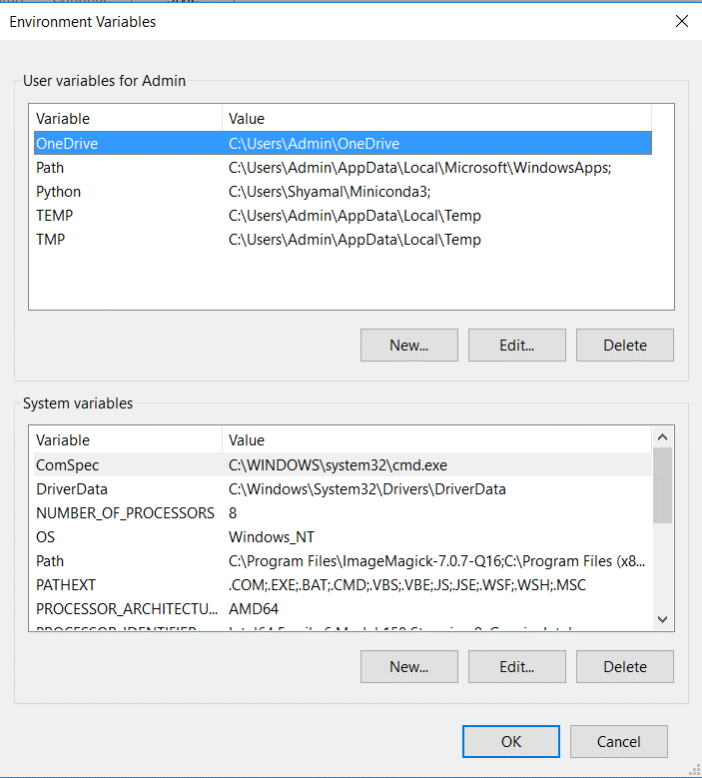

Source: Vivid Economics

Select ‘Path’ from the list of **System variables,** and click ‘Edit’

Then click ‘New’ at the ‘Edit environment variable’ window, and select ‘Browse’. Navigate to the following locations in turn, and click ‘OK’ to add them to the system path:

1. C:/Rtools/bin
2. C:/Rtools/mingw_32/bin
3. C:/Rtools/mingw_64/bin

If done correctly, your system path should contain the bottom 3 entries in the figure below.

Figure 2 Add Rtools to system path (last step)

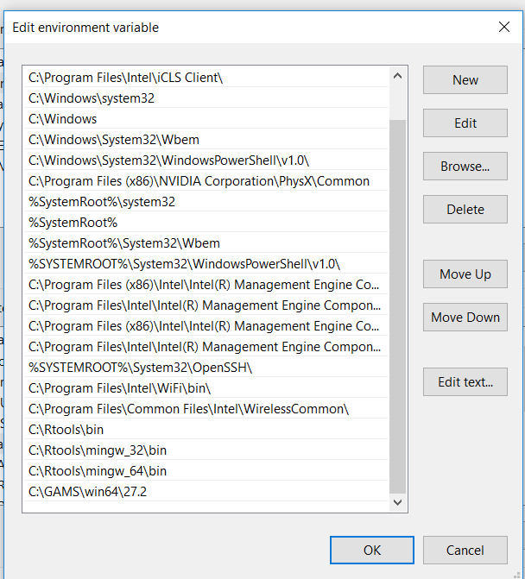

Source: Vivid Economics

Then select ‘OK’

## Install packages required for NZT

Visit <https://gitlab.com/vivideconomics/finance/171211HSB-low-carbon-portfolio-tool>, and scroll down to the README’s Prerequisites section

Open RStudio

Install all R packages listed in the Prerequisites section table **except for themeVE** by using (*note that R is case sensitive, and this may take a while because ‘tidyverse’ is a number of packages rather than one single package*):

install.packages(“<package name>”)

Visit <https://gitlab.com/vivideconomics/business-development/vivid-r-theme> and follow the ‘Getting started’ section introductions to install the themeVE package

## Download NZT code

Visit <https://gitlab.com/vivideconomics/finance/171211HSB-low-carbon-portfolio-tool> and download the code as a zip file by clicking on the button shown below.

Figure 1 Downloading the code for the mode

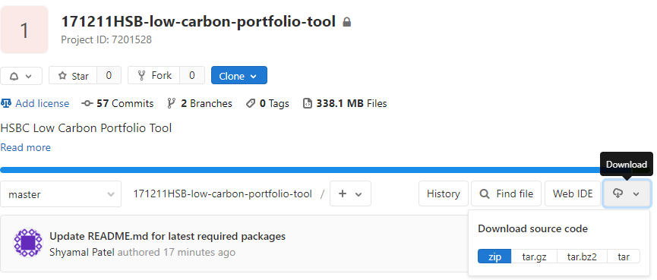

Source: Vivid Economics

Once the code has been downloaded, open the zip folder and save all the subfolders somewhere convenient.

Figure 2 Saving the code for the model

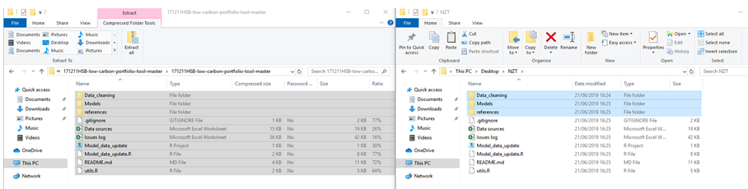

Source: Vivid Economics

## Run NZT code

### Data_cleaning

Open the R project file at the location: ‘Data_cleaning/Data_cleaning.Rproj’. If done correctly, RStudio should open and your default directory should be the ‘Data_cleaning’ folder within the code folder you saved. You can test this by typing the below into the Console:

getwd()

Click ‘Build All’ in the Build window shown below.

Figure 5 ‘Build All’ location

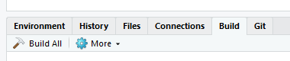

Source: Vivid Economics

Assuming everything has worked correctly until this stage, red commands will start to appear inside the Build window like the below.

Figure 6 ‘Build All’ doing its thing

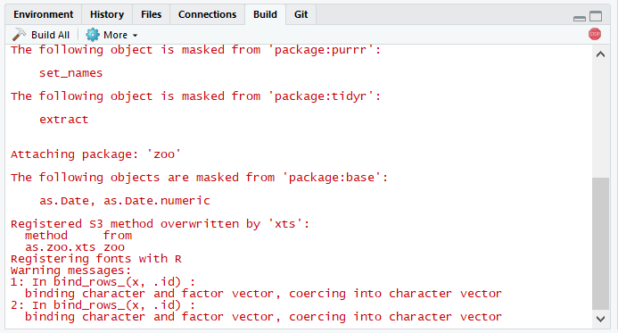

Source: Vivid Economics

This will take some time, and means R is ‘building’ all the output files in the ‘Data_cleaning’ part of the Net Zero Toolkit.

* If you’re interested in the detail, R is using *make* and the *Makefile (Data_cleaning/Makefile)* to map out which input files are required to put together the outputs specified in the *Makefile*, and then running the relevant pieces of code in the right order
* If you’re doubly interested, check out the *Makefile* itself – basically a recipe telling R how to make output files using input files and scripts

Once ‘Build all’ runs to completion, the red button in the right hand corner of the pane will disappear. If everything has worked properly, clicking ‘Build all’ will return a message that says ‘Nothing to be done for ‘all’’. This means that all output files are up-to-date, so R is not running all your scripts again to generate the output files.

If you wish to explore Outputs / Interim files from Data_cleaning, have a look through the subfolders of the ‘Data_cleaning’ folder.

Close RStudio before proceeding to the below step.

### Model data update

Open the R project folder at the root of the folder you saved (‘Model_data_update.Rproj’)

Open the script called ‘Model_data_update.R’

Run the script in its entirety (Ctrl + A to select all code in the script, and press Ctrl + Enter to run it all)

Close RStudio before proceeding to the below step. *Note that this is required every time the results of the ‘Data_cleaning’ process have changed, and is the way in which the ‘Models’ folder is updated with new inputs when the outputs from ‘Data_cleaning’ have changed.*

### Models

Open the R project folder at the location ‘Models/Models.Rproj’

Click ‘Build All’ from the ‘Build’ window as you did in step 1.7.1.

Once the red button in the right hand corner of the build window has vanished, the model has run to completion. The output folders in each of the model folders and the ‘4_Asset_impacts’ folder should now be populated with results.

To generate graphics, open and run the script ‘Models/4_Asset_impacts/Scatter_plots.R’. Outputs from this script will appear in the ‘Models/4_Asset_impacts/Output/Plots’ folder.